Data Types-Spark官方ML
Time:15/11/23~15/11/25
MLlib supports local vectors and matrices stored on a single machine, as well as distributed matrices backed by one or more RDDs. Local vectors and local matrices are simple data models that serve as public interfaces. The underlying linear algebra operations are provided by Breeze and jblas. A training example used in supervised learning is called a “labeled point” in MLlib.
local vectors和local matrices存储于单机，distributed matrices需要有RDDs的支持。

Local Vector

1.1、what is Local Vector？
A local vector has integer-typed and 0-based indices and double-typed values, stored on a single machine.MLlib supports two types of local vectors: dense and sparse. A dense vector is backed by a double array representing its entry values, while a sparse vector is backed by two parallel arrays: indices and values.
一个local vector由以0为基础的整数构成的index和double类型构成的values。MLlib支持两种local vectors：dense（稠密类型）和sparse（稀疏类型）。
dense：仅有一个double型的数组
sparse：有两个数组构成，indices和values
Example: a vector ( 1.0 , 0.0 , 3.0 )
Dense format : [ 1.0 , 0.0 , 3.0 ]
Sparse format: (3 , [ 0 , 2 ] , [ 1.0 , 2.0 ] )

1.2、who to use it？
The base class of local vectors is Vector, and we provide two implementations: DenseVector and SparseVector. We recommend using the factory methods implemented in Vectors to create local vectors.

Ex：
import org.apache.spark.mllib.linalg.{Vector, Vectors}
// Create a dense vector (1.0, 0.0, 3.0).
val dv: Vector = Vectors.dense(1.0, 0.0, 3.0)
// Create a sparse vector (1.0, 0.0, 3.0) by specifying its indices and values corresponding to nonzero entries.
val sv1: Vector = Vectors.sparse(3, Array(0, 2), Array(1.0, 3.0))
// Create a sparse vector (1.0, 0.0, 3.0) by specifying its nonzero entries.
val sv2: Vector = Vectors.sparse(3, Seq((0, 1.0), (2, 3.0)))
解析：Vectors.sparse(3, Array(0, 2), Array(1.0, 3.0))，打头的3代表的是labeledPoint的维数，Arrary（0，2）：0为Vector的基数，剩下的数字为value为0的index。第二个Array包含余下不为0的元素。

Note: Scala imports scala.collection.immutable.Vector by default, so you have to import org.apache.spark.mllib.linalg.Vector explicitly to use MLlib’s Vector.
Scala默认导入的是scala.collection.immutable.Vector，所以需要导入org.apache.spark.mllib.linalg.Vector

2、Labeled point

2.1、what is Labeled point?
A labeled point is a local vector, either dense or sparse, associated with a label/response.In MLlib, labeled points are used in supervised learning algorithms. We use a double to store a label, so we can use labeled points in both regression and classification.For binary classification, a label should be either 0 (negative) or 1 (positive). For multiclass classification, labels should be class indices starting from zero: 0, 1, 2, ....
Labeled point是一个包含label标签的local verctor。Labeled被用于监督学习算法，使用double类型存储一个label（label是labeled point的头部）可用于回归和分类。binary classification（分成两类），multiclass classification（分成多类）

2.2、how to use it？
A labeled point is represented by the case class LabeledPoint.
Ex：
import org.apache.spark.mllib.linalg.Vectorsimport
org.apache.spark.mllib.regression.LabeledPoint
// Create a labeled point with a positive label and a dense feature vector.
val pos = LabeledPoint(1.0, Vectors.dense(1.0, 0.0, 3.0))
// Create a labeled point with a negative label and a sparse feature vector.
val neg = LabeledPoint(0.0, Vectors.sparse(3, Array(0, 2), Array(1.0, 3.0)))

Sparse data
It is very common in practice to have sparse training data. MLlib supports reading training examples stored in LIBSVM format, which is the default format used by LIBSVM and LIBLINEAR. It is a text format in which each line represents a labeled sparse feature vector using the following format:
label index1:value1 index2:value2 ...
where the indices are one-based and in ascending order. After loading, the feature indices are converted to zero-based.
Txt文件中indices是以1为基数的升序数，载入后将会变为以0为底。
Ex：
MLUtils.loadLibSVMFile reads training examples stored in LIBSVM format.

import org.apache.spark.mllib.regression.LabeledPoint
import org.apache.spark.mllib.util.MLUtils
import org.apache.spark.rdd.RDD
val examples: RDD[LabeledPoint] = MLUtils.loadLibSVMFile(sc, "data/mllib/sample_libsvm_data.txt")

3、Local matrix

3.1、what is local matrix
A local matrix has integer-typed row and column indices and double-typed values, stored on a single machine. MLlib supports dense matrices, whose entry values are stored in a single double array in column-major order, and sparse matrices, whose non-zero entry values are stored in the Compressed Sparse Column (CSC) format in column-major order. For example, the following dense matrix
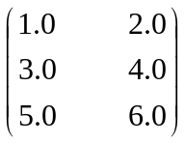
is stored in a one-dimensional array [1.0, 3.0, 5.0, 2.0, 4.0, 6.0] with the matrix size (3, 2).
Local matrix有整型的行、列标签和double类型的values构成。MLlib支持dense matrices 和sparse matrices。
dense matrices：输入的值存储在一个double类型的数组中，与列为主导方向。
sparse matrices：非零值以CSC格式存储，列为主导方向。

3.2、how to use it ?
Ex：
The base class of local matrices is Matrix, and we provide two implementations: DenseMatrix, and SparseMatrix. We recommend using the factory methods implemented in Matrices to create local matrices. Remember, local matrices in MLlib are stored in column-major order.

import org.apache.spark.mllib.linalg.{Matrix, Matrices}
// Create a dense matrix ((1.0, 2.0), (3.0, 4.0), (5.0, 6.0))
val dm: Matrix = Matrices.dense(3, 2, Array(1.0, 3.0, 5.0, 2.0, 4.0, 6.0))
// Create a sparse matrix ((9.0, 0.0), (0.0, 8.0), (0.0, 6.0))
val sm: Matrix = Matrices.sparse(3, 2, Array(0, 1, 3), Array(0, 2, 1), Array(9, 6, 8))

问题：
如何理解：Matrices.sparse(3, 2, Array(0, 1, 3), Array(0, 2, 1), Array(9, 6, 8))

查看SparseMatrix有提到CSC格式矩阵，其中给出的例子矩阵如下：
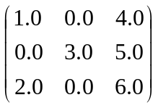
stored as values: [1.0, 2.0, 3.0, 4.0, 5.0, 6.0], rowIndices=[0, 2, 1, 0, 1, 2], colPointers=[0, 2, 3, 6]
解析：
Values:代表矩阵中所有的非零元素。
rowIndices:代表的是对应的非零元素，所对应的行号。
values | 1.0 | 2.0 | 3.0 | 4.0 | 5.0 | 6.0
rowIndices | 0 | 2 | 1 | 0 | 1 | 2
colPointers：代表的是values元素的分割点，从零开始。最后的6代表的是values结尾，其值为空。
colPointers | 0 | 2 | 3 | 6

在本例中：sparse(numRows,numCols，cloPtrs，rowIndices，values)
Values=Array(9, 6, 8)
rowIndices=Array(0, 2, 1)
cloPtrs=Array(0, 1, 3)
cloPtrs | 0 | 1 | 3

null
Values | 9 | 6 | 8
rowIndices | 0 | 2 | 1

可得矩阵：
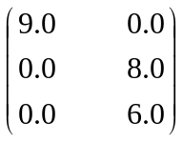

4、Distributed matrix
A distributed matrix has long-typed row and column indices and double-typed values, stored distributively in one or more RDDs. It is very important to choose the right format to store large and distributed matrices. Converting a distributed matrix to a different format may require a global shuffle, which is quite expensive. Three types of distributed matrices have been implemented so far.
①.basic type RowMatrix :is a row-oriented distributed matrix without meaningful row indices.
e.g : a collection of feature vectors. It is backed by an RDD of its rows, where each row is a local vector. We assume that the number of columns is not huge for a RowMatrix so that a single local vector can be reasonably communicated to the driver and can also be stored / operated on using a single node.
②.IndexedRowMatrix :is similar to a RowMatrix but with row indices, which can be used for identifying rows and executing joins.
③.CoordinateMatrix :is a distributed matrix stored in coordinate list (COO) format, backed by an RDD of its entries.
分布式的矩阵由长整型的行、列标签和double类型的values。选择正确的存储方式非常重要。一个分布式的矩阵转换成不同的格式需要全局shuffle，这是相当昂贵的。分布式矩阵有三种类型：
①.RowMatrix:是一个面向行的分布式矩阵，但行的indices是没有意义的。
②.IndexedRowMatrix:类似于RowMatrix但是indices具有意义。
③.CoordinateMatrix:于coordinate list格式存储的分布式矩阵。

Note
The underlying RDDs of a distributed matrix must be deterministic, because we cache the matrix size. In general the use of non-deterministic RDDs can lead to errors.
由于要缓存matrix的大小，所以RDDs必须是确定的，使用不确定的RDDs将有可能导致错误发生。

4.1、RowMatrix
A RowMatrix is a row-oriented distributed matrix without meaningful row indices, backed by an RDD of its rows, where each row is a local vector. Since each row is represented by a local vector, the number of columns is limited by the integer range but it should be much smaller in practice.
A RowMatrix can be created from an RDD[Vector] instance. Then we can compute its column summary statistics and decompositions. QR decomposition is of the form A = QR where Q is an orthogonal matrix and R is an upper triangular matrix. For singular value decomposition (SVD) and principal component analysis (PCA), please refer to Dimensionality reduction.

RowMatrix的列受限与整型范围，实际中比这还要小。RowMatrix可以由RDD[Vector]创建，我们能够进行汇总列和分解。
QR deconposition： 。。。。。。。。。。。。

E.g:
import org.apache.spark.mllib.linalg.Vector
import org.apache.spark.mllib.linalg.distributed.RowMatrix
val rows: RDD[Vector] = ... // an RDD of local vectors
// Create a RowMatrix from an RDD[Vector].
val mat: RowMatrix = new RowMatrix(rows)
// Get its size.val m = mat.numRows()
val n = mat.numCols()
// QR decomposition
val qrResult = mat.tallSkinnyQR(true)

4.2、IndexedRowMatrix
An IndexedRowMatrix is similar to a RowMatrix but with meaningful row indices. It is backed by an RDD of indexed rows, so that each row is represented by its index (long-typed) and a local vector.
An IndexedRowMatrix can be created from an RDD[IndexedRow] instance, where IndexedRow is a wrapper over (Long, Vector). An IndexedRowMatrix can be converted to a RowMatrix by dropping its row indices.
IndexedRowMatrix类似RowMatrix，但是IndexedRowMatrix是具有long类型的index和一个local vector，(Long, Vector)
通过删除行标签可将IndexedRowMatrix转换成RowMatrix
E.g：
import org.apache.spark.mllib.linalg.distributed.{IndexedRow, IndexedRowMatrix, RowMatrix}
val rows: RDD[IndexedRow] = ... // an RDD of indexed rows
// Create an IndexedRowMatrix from an RDD[IndexedRow].
val mat: IndexedRowMatrix = new IndexedRowMatrix(rows)
// Get its size.
val m = mat.numRows()
val n = mat.numCols()
// Drop its row indices.
val rowMat: RowMatrix = mat.toRowMatrix()

4.3、CoordinateMatrix
A CoordinateMatrix is a distributed matrix backed by an RDD of its entries. Each entry is a tuple of (i: Long, j: Long, value: Double), where i is the row index, j is the column index, and value is the entry value. A CoordinateMatrix should be used only when both dimensions of the matrix are huge and the matrix is very sparse.
CoordinateMatrix的每个输入都是一个元组(i: Long, j: Long, value: Double)，其中i是行的index，j是列的index，value就是value了。CoordinateMatrix用在矩阵较大而且非常稀疏的矩阵中。
E.g：

A CoordinateMatrix can be created from an RDD[MatrixEntry] instance, where MatrixEntry is a wrapper over (Long, Long, Double). A CoordinateMatrix can be converted to an IndexedRowMatrix with sparse rows by calling toIndexedRowMatrix. Other computations for CoordinateMatrix are not currently supported.

import org.apache.spark.mllib.linalg.distributed.{CoordinateMatrix, MatrixEntry}
val entries: RDD[MatrixEntry] = ... // an RDD of matrix entries
// Create a CoordinateMatrix from an RDD[MatrixEntry].
val mat: CoordinateMatrix = new CoordinateMatrix(entries)
// Get its size.
val m = mat.numRows()
val n = mat.numCols()
// Convert it to an IndexRowMatrix whose rows are sparse vectors.
val indexedRowMatrix = mat.toIndexedRowMatrix()

4.4、BlockMatrix
A BlockMatrix is a distributed matrix backed by an RDD of MatrixBlocks, where a MatrixBlock is a tuple of ((Int, Int), Matrix), where the (Int, Int) is the index of the block, and Matrix is the sub-matrix at the given index with size rowsPerBlock x colsPerBlock. BlockMatrix supports methods such as add and multiply with another BlockMatrix. BlockMatrix also has a helper function validate which can be used to check whether the BlockMatrix is set up properly.

E.g：
A BlockMatrix can be most easily created from an IndexedRowMatrix or CoordinateMatrix by calling toBlockMatrix. toBlockMatrix creates blocks of size 1024 x 1024 by default. Users may change the block size by supplying the values through toBlockMatrix(rowsPerBlock, colsPerBlock).

import org.apache.spark.mllib.linalg.distributed.{BlockMatrix, CoordinateMatrix, MatrixEntry}
val entries: RDD[MatrixEntry] = ... // an RDD of (i, j, v) matrix entries
// Create a CoordinateMatrix from an RDD[MatrixEntry].
val coordMat: CoordinateMatrix = new CoordinateMatrix(entries)
// Transform the CoordinateMatrix to a BlockMatrix
val matA: BlockMatrix = coordMat.toBlockMatrix().cache()
// Validate whether the BlockMatrix is set up properly. Throws an Exception when it is not valid.
// Nothing happens if it is valid.
matA.validate()
// Calculate A^T A.
val ata = matA.transpose.multiply(matA)

总结
主要是介绍：local vector、labeled point、local matrix、distributed matrix四种数据类型，其中distributed又由RowMatrix、IndexedRowMatrix、CoordinateMatrix、BlockMatrix构成。

参考资料：
http://spark.apache.org/docs/latest/mllib-data-types.html
稀疏矩阵：
http://demo.netfoucs.com/pipisorry/article/details/41762945#
http://www.netlib.org/linalg/html_templates/node91.html

附页：
稀疏矩阵：

Compressed Sparse Row Format (CSR)
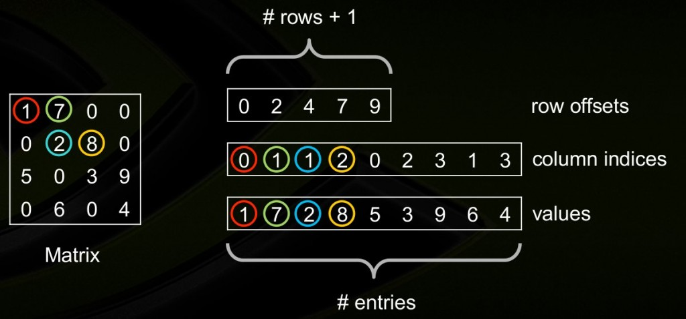
The Intel MKL compressed sparse row (CSR) format is specified by four arrays: thevalues,columns,pointerB, andpointerE. The following table describes the arrays in terms of the values, row, and column positions of the non-zero elements in a sparse matrixA.
values
A real or complex array that contains the non-zero elements ofA. Values of the non-zero elements ofA are mapped into thevalues array using the row-major storage mapping described above.
columns
Element i of the integer array columns is the number of the column inA that contains thei-th value in thevalues array.
pointerB
Element j of this integer array gives the index of the element in thevalues array that is first non-zero element in a rowj ofA. Note that this index is equal topointerB(j) -pointerB(1)+1 .
pointerE
An integer array that contains row indices, such thatpointerE(j)-pointerB(1) is the index of the element in thevalues array that is last non-zero element in a row j of A.

Compressed Sparse Column Format (CSC)
The compressed sparse column format (CSC) is similar to the CSR format, but the columns are used instead the rows. In other words, the CSC format is identical to the CSR format for the transposed matrix. The CSR format is specified by four arrays: values, columns, pointerB, and pointerE. The following table describes the arrays in terms of the values, row, and column positions of the non-zero elements in a sparse matrixA.
values
A real or complex array that contains the non-zero elements ofA. Values of the non-zero elements ofA are mapped into thevalues array using the column-major storage mapping.
rows
Element i of the integer array rows is the number of the row inA that contains thei-th value in thevalues array.
pointerB
Element j of this integer array gives the index of the element in thevalues array that is first non-zero element in a columnj ofA. Note that this index is equal topointerB(j) -pointerB(1)+1 .
pointerE
An integer array that contains column indices, such thatpointerE(j)-pointerB(1) is the index of the element in thevalues array that is last non-zero element in a column j ofA.

稀疏矩阵资料：
http://www.netlib.org/linalg/html_templates/node91.html

Compressed Row Storage (CRS)

The Compressed Row and Column (in the next section) Storage formats are the most general: they make absolutely no assumptions about the sparsity structure of the matrix, and they don't store any unnecessary elements. On the other hand, they are not very efficient, needing an indirect addressing step for every single scalar operation in a matrix-vector product or preconditioner solve.
The Compressed Row Storage (CRS) format puts the subsequent nonzeros of the matrix rows in contiguous memory locations. Assuming we have a nonsymmetric sparse matrix , we create vectors: one for floating-point numbers (val), and the other two for integers (col_ind, row_ptr). The val vector stores the values of the nonzero elements of the matrix , as they are traversed in a row-wise fashion. The col_ind vector stores the column indexes of the elements in the val vector. That is, if then . The row_ptr vector stores the locations in the val vector that start a row, that is, if then . By convention, we define , where is the number of nonzeros in the matrix . The storage savings for this approach is significant. Instead of storing elements, we need only storage locations.
As an example, consider the nonsymmetric matrix defined by
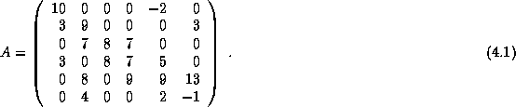
The CRS format for this matrix is then specified by the arrays {val, col_ind, row_ptr} given below

.
If the matrix is symmetric, we need only store the upper (or lower) triangular portion of the matrix. The trade-off is a more complicated algorithm with a somewhat different pattern of data access.
资料：http://www.netlib.org/linalg/html_templates/node92.html

Compressed Column Storage (CCS)

Analogous to Compressed Row Storage there is Compressed Column Storage (CCS), which is also called the Harwell-Boeing sparse matrix format [78]. The CCS format is identical to the CRS format except that the columns of are stored (traversed) instead of the rows. In other words, the CCS format is the CRS format for .
The CCS format is specified by the arrays {val, row_ind, col_ptr}, where row_ind stores the row indices of each nonzero, and col_ptr stores the index of the elements in val which start a column of . The CCS format for the matrix in () is given by

